News From Kaharoa School 37.9959° S, 176.2347° E

June 2021

Well, the cooler weather is here with us now and we are having some lovely crisp days here in Kaharoa.

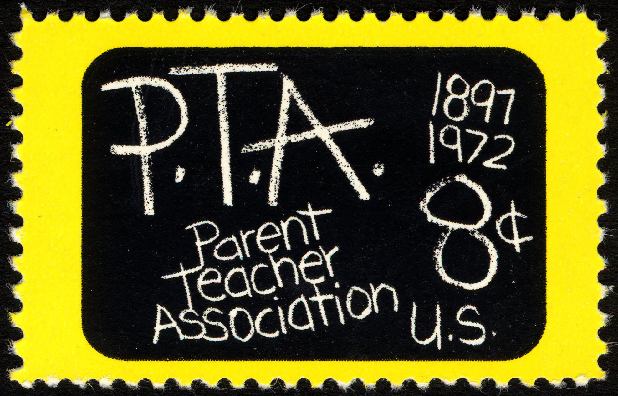**PTA** - our very active PTA group held their AGM last month and new officers were elected along with committee members. Alongside the AGM our very capable year 8 leaders ran a disco for the children so parents could attend the AGM. Lots of dancing and games were enjoyed by all the children. Our PTA runs many activities for our children.

**Pink Shirt Day**-in collaboration with the Mental Health Foundation we supported Pink Shirt Day. The school was awash with outfits of various pink hues. Thank you to all those children and parents who supported this day.

**Reminder**-that Queen's Birthday is Monday 7th June. Happy Birthday to Elizabeth and to everyone else, enjoy your long weekend.

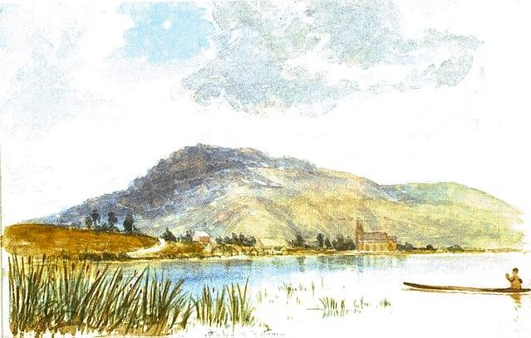**Te Maru o Ngongotaha Kahui Ako - Teacher Only Day**-this was held on Tuesday 8th June and our staff attended, and learned alongside other schools in our CoL at Kaitao Intermediate.

**NZ Playhouse**-we are excited to have the NZ Playhouse perform for us this month. This year's production is Rumpelstiltskin. It is a hilarious and interactive adaptation of Grimm’s beloved fairy tale and will have everyone thinking about the value of kindness and cooperation; the consequences of not telling the truth and the importance of keeping a promise.

**Cross Country**-this year our cross county will be held on Tuesday 22nd June.

Our children are currently training for this event with their classmates. We are so fortunate to be able to have a wonderful course to run this event thanks to the Walshe, Bridge and Freiesleben families who generously open their farms which enables our cross country to be a real cross country.

**Paid Union Meeting**-on Thursday 24th June our teachers will be at a paid union meeting. Our school will be open for our tamariki.

**Disco**-our year 8 leaders are organising a disco as one of their fundraising events for this term. This provides another fun event for our tamarki but also to raise money for the year 8 projects.

**New Principal**- On Wednesday 9th June a pōwhiri was held to welcome Lynden Cook to our staff as our new principal. Lynden has moved over from Hamilton Christian School. Staff, children and parents are looking forward to having Lynden join our Kaharoa Team.



Please refer to the Kaharoa website for further information. [www.kaharoa.school.nz](http://www.kaharoa.school.nz)

Ngā mihi mahana - The Kaharoa Team